Project 1: 2-D Thermal Analysis

**Xin Yu**

**xinyu@andrew.cmu.edu**

##### Abstract

In this project, I simulate a 2D steady-state thermal problem in matlab. Given a heat equation as a 2nd-order linear PDE, solve it by both Gaussian elimination and Cholesky factorization and finally display the temperature distribution in the medium in graph.

# 1. Mathematical Formulation

Given the thermal PDE :

$$ρ.C_{P}.\frac{∂T(x,y,t)}{∂t}=κ.∇^{2}T(x,y,t)+f(x,y,t)$$

Simplify the problem with the steady state assumption:

$$κ.∇^{2}T(x,y)+f(x,y) = 0$$

Discretize heat equation:

$$κ.[\frac{T_{i+1,j }+T_{i-1,j }-2T_{i,j }}{∆x^{2}} +\frac{T_{i,j+1 }+T_{i,j-1 }-2T_{i,j }}{∆y^{2}}]=-f(x,y)$$

The following four steps describe how to solve the numerical problem in matlab.

1. Define the system with a linear equation:

$$AX =B$$

Initialize B vector with “heat source ” and “boundary condition”.

1. Compute the coefficient matrix with discretized heat equation, which is symmetrical and positive defined.
2. Implement Gaussian elimination and Cholesky factorization to solve the linear equation.

1)The basic idea of **Gaussian elimination** is to transform A to an upper triangle matrix, and compute the unknown variables backwards.

2)The main work of **Cholesky factorization** is to decompose A = LL’(L is lower triangle matrix), then solve the linear equations as:

$$\left\{\begin{aligned}LV=B \\ V=L^{'}X\end{aligned}\right.$$

1. Display the solver for each case in graph.

**2. Linear System Solver**

Steps to implement **Gaussian elimination** :

1: Compute the ratio:

$${ratio}_{11 }=a_{21}/a_{11}$$ 2: Compute the next row vector:

$$A_{2}=A_{2}-{ratio}_{11}.A_{1}$$

3: Replace old $A_{2}$  with updated vector $A_{2}$

4: Repeat from step 1 Step 3 , transforming A to an upper triangle matrix.

Steps to implement **Cholesky factorization:**

1: Compute the scalar:

$$λ_{11 }=\sqrt{a_{11}}$$ 2: Compute the column vector:

$$l_{21}=a_{21}/λ_{11}$$ 3: Compute the matrix :

$$A_{22}=l_{21}l_{21}^{T}+L_{22}L_{22}^{T}$$

4: Replace A with $A_{22}$  :

$$A =A_{22}$$ 5: Repeat from step 1 till the matrix size at Step 4 becomes 1×1.

# 3. Experimental Results

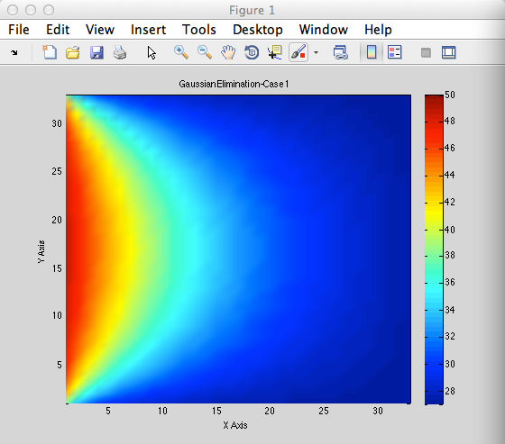

*Elapsed time is 11.137160 seconds.*

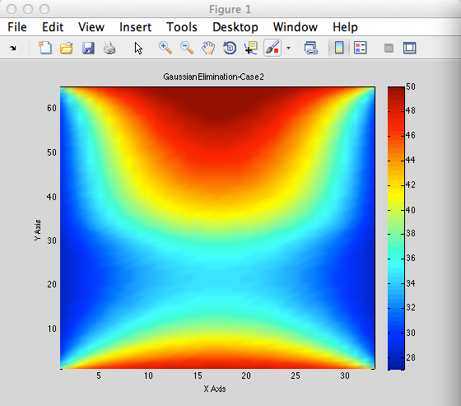

*Elapsed time is 94.899312 seconds*

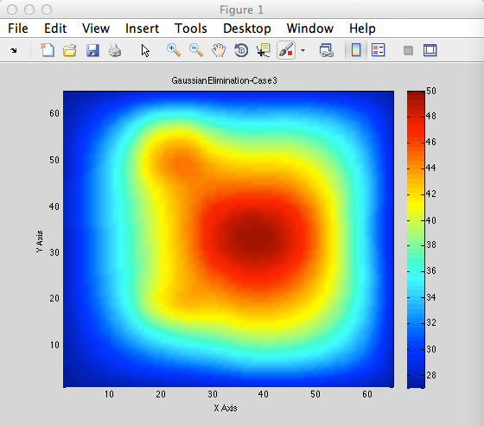

*Elapsed time is 938.885024 seconds.*

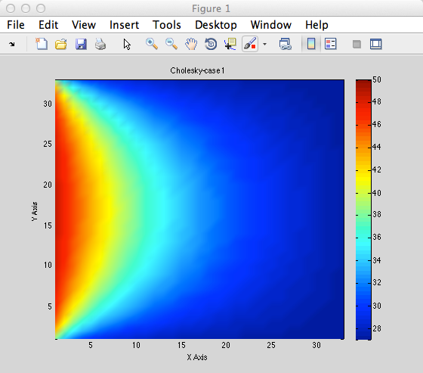

*Elapsed time is 12.113527 seconds.*

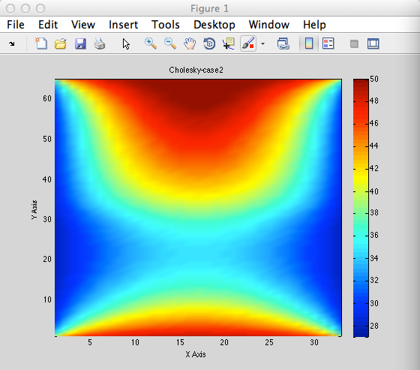

*Elapsed time is 104.104134 seconds.*

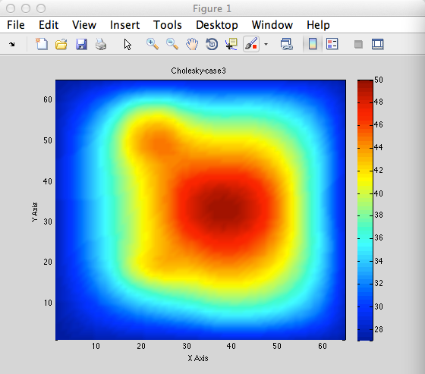

*Elapsed time is 949.839249 seconds.*

# 4. Discussion

* *Accuracy and efficiency your program can achieve*

Compared with two methods, Gaussian elimination seems to have higher efficiency. The reason for that is Gaussian algorithm can solve the problem by calculating the triangle matrix once, while Cholesky needs to solve two triangle matrix (A = LL’).

* *Size of problem your program can handle*

Obviously, the larger size of input, the longer time it takes to solve the problem in matlab. For now, even though a 65-by-65 input works pretty well, it takes about 10 mins to give the completed solution. However, I am pretty sure , it is able to handle larger size of problem in this case.

* *Possible improvements that can be done*

For Gaussian algorithm, we can use bsxfun function instead of for loop to initialize the coefficient matrix or matrix transformation, which might save plenty of time. Besides, it is super neat to encapsulate the algorithm part as a function,

* *Anything you have done to improve/validate your program’s accuracy/efficiency.*

In order to get higher efficiency in debugging, I wrote a demo.m script to test both of my functions, which can load any data case or choose any function you want to run without tying in command window.

# References

1. <http://www.mathworks.com/matlabcentral/fileexchange/39850-matlab-code-gaussian-elimination-method>.
2. <http://www.mathworks.com/help/symbolic/mupad_ref/linalg-factorcholesky.html>
3. <http://www.gaussianwaves.com/2013/05/cholesky-factorization-and-matlab-code/>